The Parekh Family Foundation
The Gunvant & Bharati Parekh College Scholarship

The Parekh Family Foundation was established in 2006, in memory of Gunvant Parekh and Bharati Parekh. The Parekh Family Foundation is a non-profit, private operating foundation, focusing on activities that embody the ideals and values of the late Gunvant and Bharati Parekh. These activities include supporting education, research, and missionary medical aid to those who need health care within the United States and abroad.
In Education, the Foundation is committed to:
- Strengthening the medical profession by providing business education to future physicians and health care professionals.
- Attracting, developing, motivating and retaining the best talent to the healthcare profession.
- Stimulating creativity and productivity among young people and adults through programs that encourage and support learning as a lifelong process.
In Medical Research and Missionary Aid, the Foundation is committed to:
- Advancing and supporting basic and applied medical research and aid –especially in geographic areas of dire need.
- Supporting basic health care programs to assure the well-being of community members of all ages.
- Building vibrant communities by involving people of all ages in health programs that contribute to the well-being of their community and its residents.
We encourage all applicable students to apply.
Selene and Zankhna Parekh
Founders
Parekh Family Foundation
Gunvant & Bharati Parekh College Scholarship
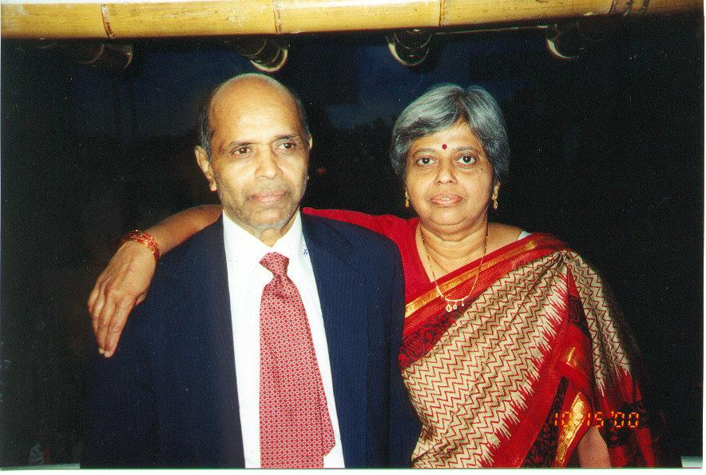Gunvant & Bharati Parekh immigrated to the USA in the late 60’s. With hopes for a better future, they believed in core Indian principles, raising their kids in the traditions and customs of their motherland.

Gunvant Parekh was a forward-thinking pioneer, being the first in his family to leave India. He established himself in a new country and helped his extended family settle in America. Despite moving to a new country, he never forgot the core Indian values he was raised with. He was a disciplined, and principled individual, but always valued family over all else. He was a foodie, dancer, and lover of life.

Bharati Parekh was a caring, selfless human being who touched the lives of everyone who knew her. She was a bright woman, educated as a chemist and finished at the top of her class in Gujarat! Always with a smile, she was a devoted wife, mother, grandmother, friend, and person, seeing the best in everything.

Eligibility
Two scholarships will be awarded to students in the United States who are seniors in high school or current college students, who are actively enrolled in a college in the United States as of September 2024. The student must be of Indian origin, and must demonstrate academic and personal excellence.

Amount
A one-time $1,000.00 check will be awarded to two students each to help defray the cost of tuition, room and board, or books.

Application Process
The applicant must complete the attached form and video essays.

Deadline for Application
The deadline for applying for this scholarship is June 1, 2024. Completed applications must be submitted by email to: parekhscholarship@gmail.com. Please note that no late applications will be accepted.

Announcement of Scholar
The scholar will be announced and notified on August 1, 2024.

Gunvant and Bharati Parekh Scholarship Application

General Information:

First Name Middle Name Last Name

Address
Street: City: State: Zip Code:

Name of high school:

High school GPA (written as your GPA / max GPA):

High school graduation year:

SAT score (if applicable): ACT score (if applicable):

High school extracurricular activities:

High school leadership experience:

Name of college you are attending / will attend as of August 2022:

College GPA (written as your GPA / max GPA):

College graduation year:

Major(s):

Minor(s) (if applicable):

College extracurricular activities:

College leadership experience:

-------------------------------------------------------------------------------------------------------------------------------

Video instructions and guidelines:
- Using a smartphone, video camera, computer, etc., please create a short video (no more than 90 seconds) that responds to the prompts below
- How you choose to answer the prompt is completely up to you. Be as creative and as thoughtful as you would like.
- Be sure to state your first and last name in the beginning of the video.
- Please upload your video to youtube.com. Provide us with the link to your private video in the field below. We encourage applicants to make their YouTube videos unlisted so that the video and link are only accessible to those who have been given the link. Please keep all videos active until September 30, 2024.
- Please note videos will not be evaluated based on production quality.

Discussion Questions:

All questions must be answered by video, each answer no longer than 90 seconds:

  - Describe a project or initiative you undertook that had a significant positive impact on your community. How did you identify the need, and what steps did you take to address it?

  - Discuss how your cultural heritage and personal identity have influenced your educational journey and career aspirations.

Link to private YouTube video:

-------------------------------------------------------------------------------------------------------------------------------
Please attach the following to your application:
- A picture of yourself
- High school transcript
- Activities and hobbies list
- College / University unofficial transcript (if applicable)

Send completed applications and attachments to: parekhscholarship@gmail.com by June 1, 2024. No exceptions will be made to this deadline.

